UNIVERSITY OF GHANA
DEPARTMENT STATISTICS AND ACTUARIAL SCIENCE
ASTA607 – COMPUTATIONAL STATISTICS I
CONFIDENCE ENAM SEKYERE
22427343

Question 1

str(Animals)library(MASS)
data(crabs)

Output: body brain
Mountain beaver 1.35 8.1
Cow 465.00 423.0
Grey wolf 36.33 119.5
Goat 27.66 115.0
Guinea pig 1.04 5.5
Dipliodocus 11700.00 50.0

Comment: The data is indeed a balanced data

Question 2

str(crabs)
par(mfrow = c(1,2)) # display side by side

hist(crabs$CL[crabs$sp=="B"],
main = "Carapace Length - Blue Species",
xlab = "Carapace Length (mm)",
col = "lightblue",
breaks = 10)

hist(crabs$CL[crabs$sp=="B"],
main = "Carapace Length - Blue Species",
xlab = "Carapace Length (mm)",
col = "lightblue",
breaks = 10)

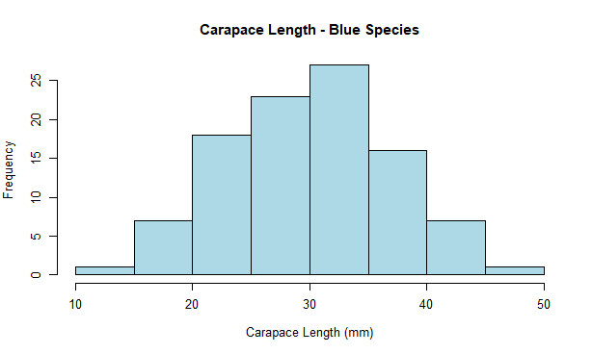

Question 3

hist(crabs$CL[crabs$sp=="O"],
main = "Carapace Length - Orange Species",
xlab = "Carapace Length (mm)",
col = "orange",
breaks = 10)
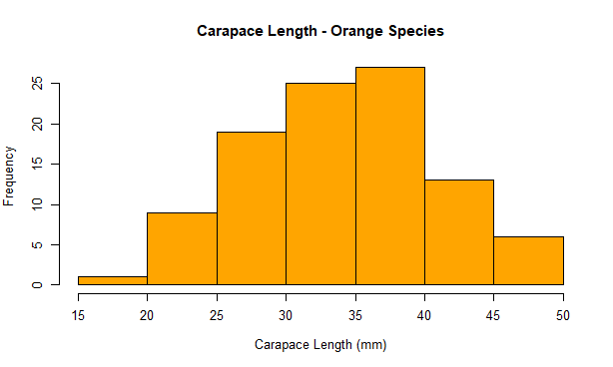

Question 4
barplot(t(means_matrix),
beside = TRUE,
legend.text = colnames(means_matrix),
col = rainbow(5),
main = "Mean Morphological Measurements by Species and Sex",
xlab = "Species and Sex Groups",
ylab = "Mean Measurement")
library(MASS)
data(crabs)
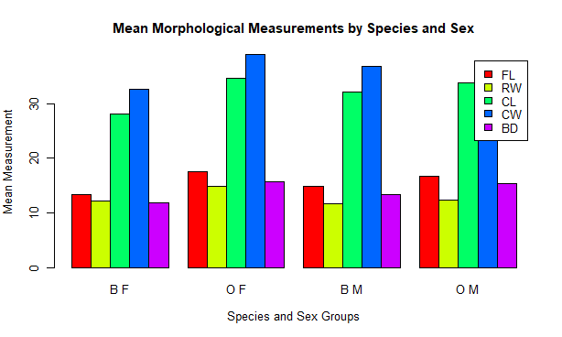

Question 5

# Produce pairs plot
pairs(measurements,
main = "Scatter Plot Matrix of Morphological Measurements",
pch = 19,
col = "darkblue")

q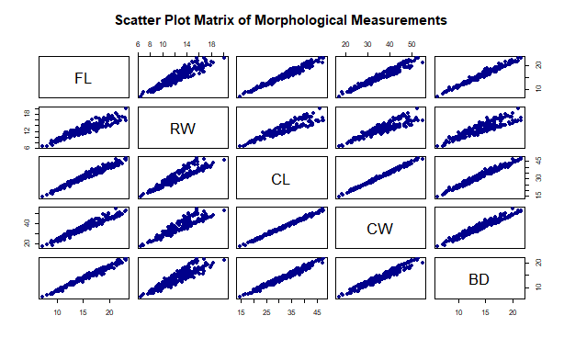
Strength and relationship among variables
There is an indication of very strong positive linear relationships between the variables

Question 6
Comprehensive statistical report
This report presents an analysis of morphological measurements from the crabs dataset in the MASS. The data consist of 200 crabs classified by species (Blue and Orange) and sex (Male and Female). For each crab, five morphological measurements were recorded
The aim of this analysis is to examine group composition, compare body size across species and sex, explore distribution of carapace length, evaluate group differences in average morphology, and assess relationships among the five measurements.

